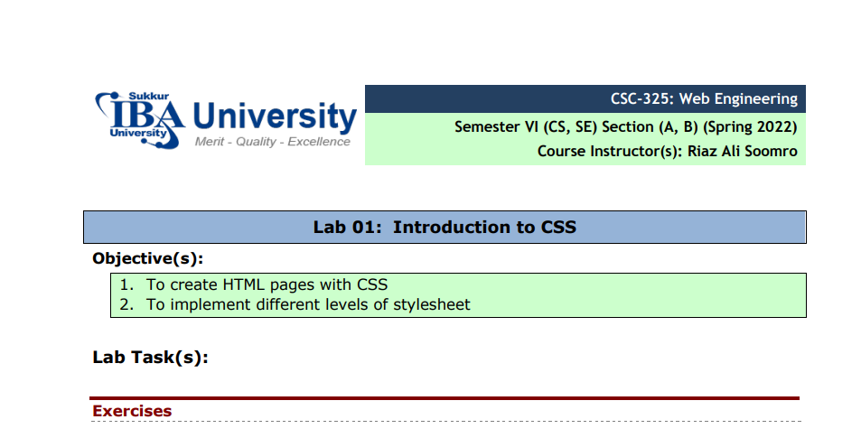
- Create the following payment form using HTML and CSS. Note: This is just a sample: Each student should apply different/unique styles
- <!DOCTYPE html>
- <HTML>
- <HEADer>
- <style>
- .container
- {
- margin-left: 30%;
- margin-right: 30%;

- }
- .form{

- background-color: lightblue;
- padding: 20px;
- border: black solid 2px;
- border-radius: 10px;

- }
- .elements{
- border-radius: 10px;
- margin-left: 6px;
- margin-right: 6px;
- padding: 5px;
- margin-bottom: 5px;
- border: black solid 2px;
- background-color:lightpink;
- align-items: center;
- align-self: center;
- align-content: center;
- text-align: center;
- word-spacing: 100px;
- position: relative;

- }
- label{
- /* width: 100%; */
- position:absolute;
- left: 20px;
- top: 10px;

- }
- input{
- width: 50%;
- padding: 5px;
- border-radius: 5px;
- margin-left:10px ;

- }
- textarea{
- width: 50%;
- border-radius: 10px;
- margin-left:10px ;

- }
- .flex-container{
- display: inline-block !important;
- /* height: 100px; */
- width: 150px !important;
- padding: 2px;
- margin-bottom: 10px;

- }
- .flex-container>input{
- width: 20px;

- }
- .but{
- text-align: right;
- margin-top: 20px;
- margin-bottom: 20px;
- width: 100%;
- margin-right: 40px;

- }
- button{
- font-size: 30px;
- background-color: lightpink;
- font-weight: bold;
- border-radius: 10px;

- }
- </style>
- </HEADer>
- <body>
- <div class="container">
- <h2>Payment Form</h2>
- <div class="form">
- <h3>Step 1: Your Details </h3>
- <div class="elements">
- <label for="name">Name</label>
- <input type="text" name="name" placeholder="Full Name">
- </div>

- <div class="elements">
- <label for="email">Email</label>
- <input type="text" name="email" placeholder="email">
- </div>

- <div class="elements">
- <label for="phone">phone</label>
- <input type="text" name="phone" placeholder="phone">
- </div>
- <h3>Step 2: Delivery Address </h3>
- <div class="elements">
- <label for="Address">Address</label>
- <textarea name="" id="" cols="20" rows="5">Adress</textarea>
- </div>
- <div class="elements">
- <label for="phone">Post-Code</label>
- <input type="text" name="phone" placeholder="postcode">
- </div>
- <div class="elements">
- <label for="phone">Country</label>
- <input type="text" name="phone" placeholder="Country">
- </div>

- <h3>Step 3: Card Details </h3>

- <div class="flex-container"><input type="radio"><img src="visa.png" alt="" width="15px"> <span>Visa</span></div>
- <div class="flex-container"><input type="radio"><img src="debit.png" alt="" width="15px"> <span>debit</span></div>
- <div class="flex-container"><input type="radio"><img src="mastercard.jpg" alt="" width="15px"> <span>mastercard</span></div>

- <div class="elements">
- <label for="phone">Card-Number</label>
- <input type="text" name="phone" placeholder="Card Number">
- </div>
- <div class="elements">
- <label for="phone">Security-Code</label>
- <input type="text" name="phone" placeholder="Card Number">
- </div>
- <div class="elements">
- <label for="phone">Name-on-card</label>
- <input type="text" name="phone" placeholder="Card Number">
- </div>

- <div class="but"> <button >BUY IT</button></div>
- </div>
- </div>
- </body>
- </HTML>

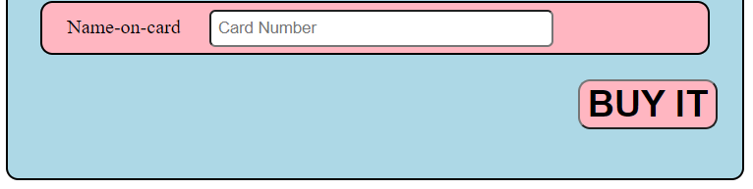
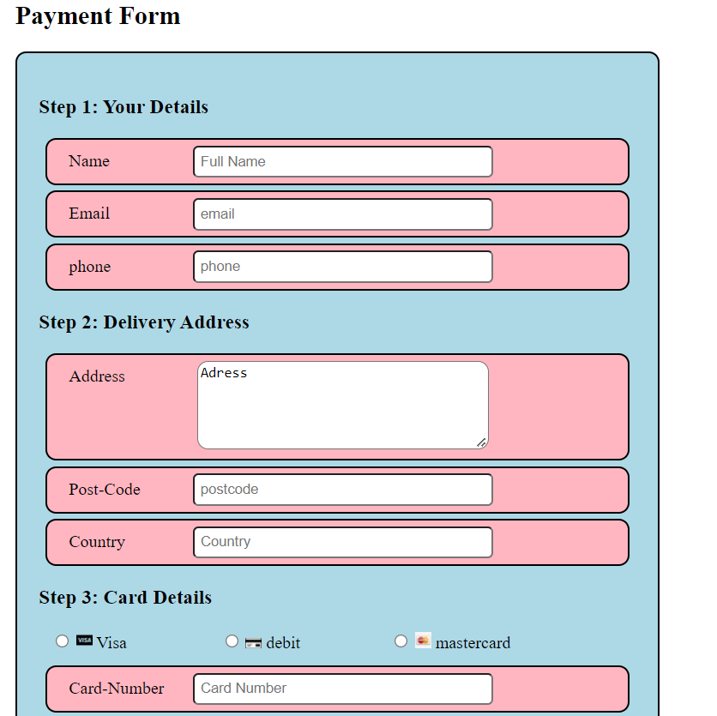

2. Design given below layout of a page using HTML5 elements and apply required CSS.

<!DOCTYPE html>
<html lang="en">
<head>
<meta charset="UTF-8">
<meta http-equiv="X-UA-Compatible" content="IE=edge">
<meta name="viewport" content="width=device-width, initial-scale=1.0">
<title>Document</title>
<!-- <link rel="stylesheet" href="style2.css"> -->
<style>
.head{
text-align: center;
padding: 1px;
/* width: 100%; */
background-color:darkblue;
color: aliceblue;
margin-left: 10px;
margin-right: 10px;

}
.flexb{
display: flex;
justify-content: space-around;
height: 550px;
}
.flexb>div{
/* background-color: #f1f1f1; */
display: inline-block;
margin-left: 2px;
margin-right: 2px;
text-align: center;
padding: 10px;

}
.foot{
text-align: center;
padding: 1px;
/* width: 100%; */
background-color:darkblue;
color: aliceblue;
margin-left: 10px;
margin-right: 10px;
}

.a{
/* background-color: aqua !important; */
width: 56%;
height: 600px;
text-align: center;
float: left;

}
.b{
background-color:lightblue !important;
width: 40%;
height: 500px;
text-align: center;
/* float: left; */
margin-top: 20px;
display: flex;
align-items: center;

}
article
{
font-size: 40px;
text-align: center;
}
table{

padding: 2px;
width: 100%;

}
tr{
background-color: aqua;
}
.b>div{
text-align: center;
margin-top: 120px;
background-color: aliceblue;
}
</style>
</head>
<body>
<div class="head">
<h3>Header</h3>
</div>
<div class="flexb">
<div class="a">
<div class="art">
<table cellspacing="10px">
<tr>
<td>
<article>
article 1
</article>

</td>
</tr>
<tr>
<td>
<article>
article 1
</article>

</td>
</tr>
<tr>
<td>
<article>
article 1
</article>

</td>
</tr>
<tr>
<td>
<article>
article 1
</article>

</td>
</tr>
<tr>
<td>
<article>
article 1
</article>

</td>
</tr>
<tr>
<td>
<article>
article 1
</article>

</td>
</tr>
<tr>
<td>
<article>
article 1
</article>

</td>
</tr>
<tr>
<td>
<article>
article 1
</article>

</td>
</tr>
<tr>
<td>
<article>
article 1
</article>

</td>
</tr>
</table>
</div>
</div>
<div class="b" style="text-align: center;">
<div>
<table >
<tr style="background-color: lightblue !important;"><td> <article>
aside
</article></td></tr>
</table>
</div>

</div>
</div>
<div class="foot">
<footer>
<h3>Footer</h3>
</footer>
</div>
</body>
</html>

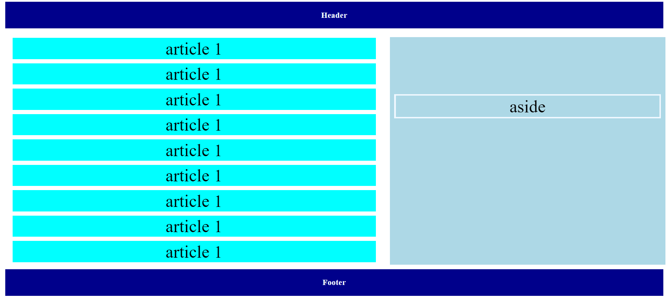

3. Create a below given page using HTML & CSS.
<!DOCTYPE html>
<html>
<head>
<!-- <link rel="stylesheet" href="style3.css"> -->
<style>
.cont{

background-color:darkgray;
width: 100%;
height: 500px;
/* display: inline-block; */

}
.cont>div{
display:inline-block;
margin-top: 10px;
}
hr{
border: 1px solid black;
}
span{
font-size: 40px;
font-family:Georgia, 'Times New Roman', Times, serif;
}

.div1

{
/* float: left; */
width: 15%;
margin-left:10px ;

}
p{
font-size: 15px;
}
table{
width: 100%;
padding: 10px;
border-spacing:0 10px ;
}

.div2{
top: 20px;
margin-left: 10px;
padding-left: 20px;
/* text-align: center; */
width: 80%;
position: fixed;
/* background-color: antiquewhite; */
}

</style>
</head>
<body>

<div class="cont">
<div class="div1">
<table cellpadding="10px">
<tr>
<td style="width: 200px;background-color: aliceblue;">Home Page</td>
<td style="background-color: chartreuse;width: 20px;"> </td>
</tr>
<tr>
<td style="width: 200px;background-color: aliceblue;">About</td>
<td style="background-color: chartreuse;width: 20px;"> </td>

</tr>
<tr>
<td style="width: 200px;background-color: aliceblue;">Contact us</td>
<td style="background-color: chartreuse;width: 20px;"> </td>
</tr>
<tr>
<td style="width: 200px;background-color: aliceblue;">Others</td>
<td style="background-color: chartreuse;width: 20px;"> </td>
</tr>

</table>
</div>
<div class="div2">
<h1>My First Page STyles With CSS</h1>
<h3>WelCome to My Page</h3>
<p>
Lorem ipsum dolor sit amet consectetur adipisicing elit. Reiciendis, ullam eum? Repellat facilis nisi numquam. Quasi magni voluptatibus minus nesciunt quis aliquid vero nam, sunt laborum? Consectetur ratione quidem repudiandae dolores mollitia laborum blanditiis cumque eius expedita dolore? Delectus quam velit accusamus exercitationem, voluptas autem inventore blanditiis quibusdam architecto, beatae recusandae. Architecto iste, consequuntur praesentium neque maiores quia corporis reiciendis cum hic dolorum provident, eveniet amet. Consequatur nostrum officiis rerum perspiciatis consectetur, dolorum quisquam velit temporibus illum, atque quibusdam vitae sunt rem eos? Ratione, dignissimos consectetur, dolores harum praesentium ipsam optio, voluptates dolorem tempora sunt commodi tempore et ipsa sed!
<br><br>
Lorem ipsum dolor sit amet consectetur adipisicing elit. Dolore maiores voluptates incidunt eligendi eius possimus temporibus ratione illum repellat ad molestias obcaecati nostrum distinctio quas, enim doloremque cupiditate officia omnis laborum reprehenderit quae dolor. Quia, fuga nemo. Dignissimos qui sint provident veniam ipsam ullam, esse doloremque delectus dolore quasi unde adipisci obcaecati quos! Atque veritatis totam possimus, obcaecati ullam amet excepturi nam aliquid saepe delectus optio facere, reiciendis nisi fuga! Iste repellat, atque deleniti, optio velit ratione nulla illum suscipit sapiente, illo fugiat? Dignissimos sint excepturi quas? In voluptate, est natus nobis, facere ducimus sit esse similique autem nisi asperiores!
</p>
<br>
<br><br>
<br>

<hr>
<span>22 Feb 2022</span>
<br>
<br>
</div>
</div>

</body>
</html>

